COMMUNICATION DIAGRAMS

Access Control and Security

1. Login
2. Verification of username/password
3. Multi-factor request
4. MFA code
5. Analytics access
6. Analytics are displayed

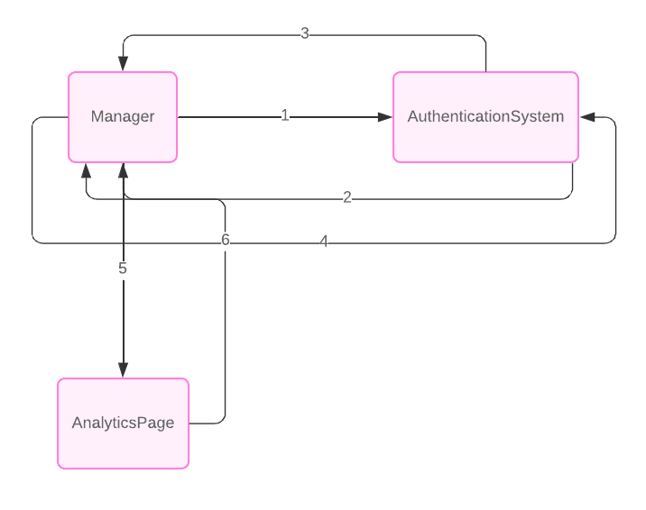

Mobile Compatibility

1. Request mobile view
2. Render mobile interface
3. Mobile interface displayed
4. Mobile view ready

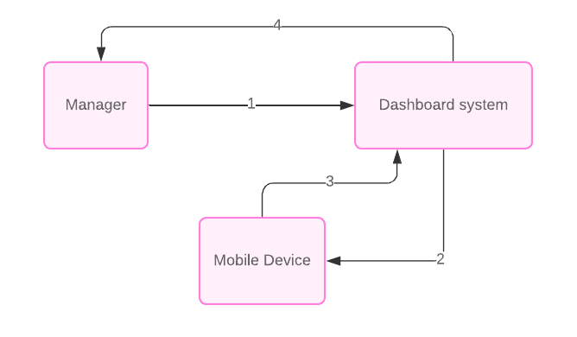

Dashboard including Visual Display

1. Request dashboard with visual display
2. Sends data for visualization
3. Visuals are created
4. Dashboard is displayed

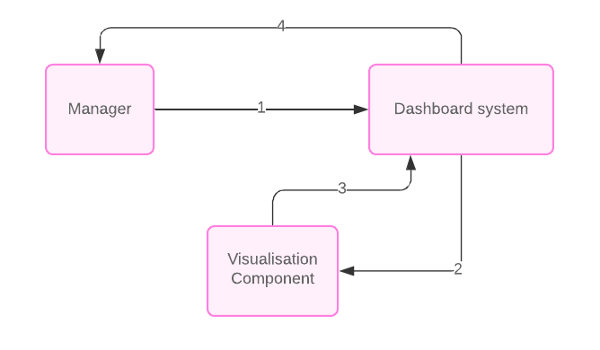

Real-Time Data Updates

1. Request data updates
2. Retrieve the data
3. Send the data
4. Display the data

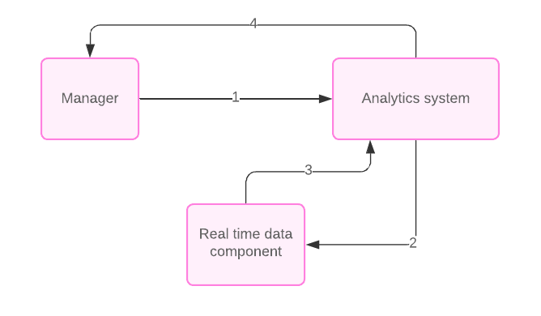

Filtering and Sorting Options

1. Request the options
2. Retrieve filter options
3. Send filter options
4. Retrieve sorting options
5. Send sorting options
6. Display all options

